Post-COVID symptoms (long COVID) in children and young people – Activity

If you have had COVID-19 (coronavirus) you might have symptoms that last for a few weeks or months. This is sometimes called post-COVID or long COVID. This information gives you some ideas of things you can do to make sure that you get back to your normal activities as easily and quickly as possible.

Managing your activity with long COVID
When you have been unwell with long COVID symptoms, you might find it difficult to take part in daily activities, or manage them to the same level as you did before. You might get more, or worse, symptoms after some activities and find you need to rest or sleep more.

It is important to build up activity gradually and not to rush back to activities too quickly. It might take longer than you expect.

There are ways to help you to manage activity better, and get back to the things you want to do.

Remember that everyone is different and you might need to adapt things for your own situation.

- If your symptoms are mild, you might be able to progress more quickly.
- If your symptoms are severe you might need a bit longer, but might still find the suggestions outlined helpful.

Types of activity
Activities can be physical, such as walking, or cognitive (needing concentration and memory), like schoolwork. Most activities are a mixture of both, and all activities use energy. Each person finds different activities less or more demanding.

- Cognitive activities include concentrating on schoolwork or a film, talking to friends, playing video games, reading or texting.
- Physical activities include functional things such as climbing the stairs, washing your hair, walking to school or just sitting out of bed, and enjoyable things like baking a cake.

Any kind of movement uses energy, not just exercise and sport.

Things that can help activity levels
Boom and bust
It can be frustrating and upsetting when you cannot do the things you want to do. It can also be tempting to do more on a day when you feel better, or when you might miss an important activity. This can make your symptoms worse and be followed by a period of having to rest more to recover.

We call this activity pattern ‘boom and bust’. Over time, boom and bust can lead to less activity and it can make it more difficult to manage your symptoms.

Many young people report that pacing their activity is a good way to manage their energy better and reduce flare-ups in symptoms.
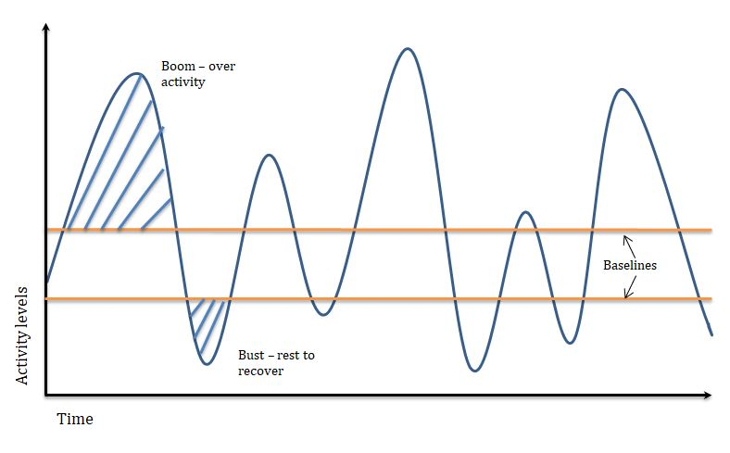
Time
Activity levels

Boom
(over activity)

Bust
(rest to recover)
Pacing
Pacing is way of balancing activity and rest. It can help you to find a manageable routine with realistic amounts of sleep, rest, activity and social interaction. This helps you to make activity and energy levels more consistent and reduce setbacks. Before starting to increase your activity, it is helpful to stabilise your routine.

Rest
Getting regular, good quality rest is important for your recovery. Take regular rest breaks throughout the day before you get too tired.

Restful activities are different for everyone.
- Try different relaxing activities such as reading, drawing, listening to music, simple breathing exercises or mindfulness.
- Try to avoid using screens when resting.
- Although taking rest breaks is helpful, sleeping in the day can have a negative impact on the quality of your night-time sleep. You might find it helpful to reduce daytime naps.
- Taking regular rests to recharge and recover will help you to manage your energy. Try to avoid getting over-tired.

Starting a routine
Try to have a good pattern of sleep, mealtimes, activity and rest. Having a regular routine, that has some flexibility, can be helpful and can also help you sleep better.

It can take time to work out how much activity is manageable without making your symptoms worse. Using an activity diary, activity tracker or step counter can be a helpful way to track activity to help set realistic activity limits. Remember that all types of activity have an impact, so pacing applies to thinking, social and emotional activities as well as physical ones.

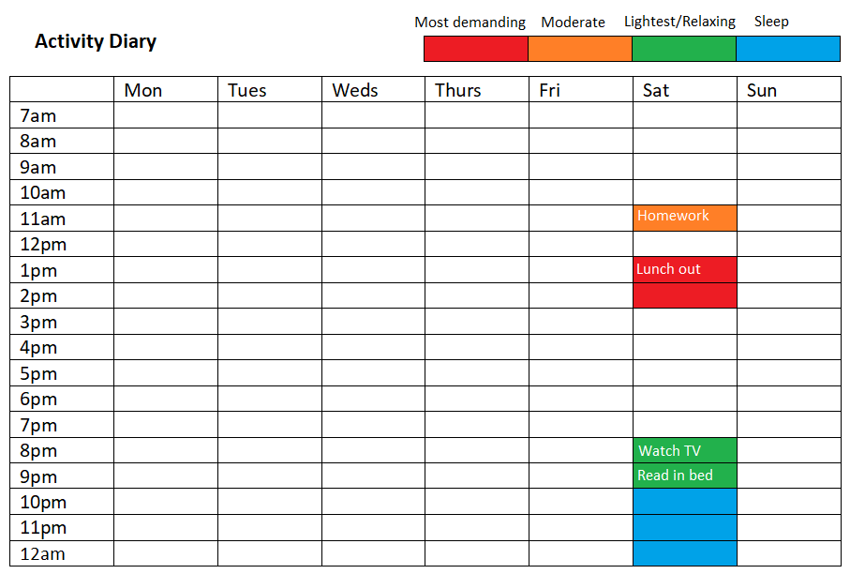
Filling in an activity diary for 1 to 2 weeks can help you find patterns in your current activity.
Here is an example with one day partially filled in. Try to fill in the whole week to see your overall activity and types of activity.
Setting a baseline
Your baseline is the amount of activity you can do regularly without making your symptoms worse. It can be for a particular activity, or for different activities over a day or week.

If you are unsure of your baseline, start by doing less than you think
you can do. It is better to do a little activity more often, than a lot occasionally.

- Stick to set limits to avoid a boom and bust pattern.
- Spread activities evenly over the day and the week.
- Remember to take regular breaks to rest between activities.
- It can be helpful to alternate physical and mental activities.
- Planning what you are going to do in advance can help you stick to your baseline.

Example of baseline for an activity
If you can walk for 20 minutes on a better day with a possible increase in symptoms afterwards, but you could only walk for 5 minutes comfortably on most days, your baseline for walking is 5 minutes.

Do the activities you enjoy
It is important to include some enjoyable activities in your daily routine, and not just things you have to do, such as school work. At first, you might not be able to manage tasks in the way that you used to. You might have to experiment with doing things slightly differently to get back to things you enjoy.

Example of doing things differently
If you wanted to bake a cake, but think it might be too much for you, see if you can do things differently. This could be starting with a simple recipe, breaking the task down into smaller chunks, getting some help, taking regular rest breaks, or sitting-down rather than standing up.

You might find it helpful to focus on 1 activity at a time, and limit other distractions that might make concentrating more difficult. For example, putting your phone away and sitting in a calm quiet space to read or study.

It is not always possible to pace activities completely, so do not worry if things do not always go as you planned. Sticking to planned amounts of activity as much as possible is a good way to start.

If you think you have set your baseline too high or too low you can always adjust it. As your symptoms improve you might be able to relax the rules a bit if there is something important that you want to join in with.

Key points
- Find a manageable amount of activity that works for you (a baseline).
- Try to keep sleep, wake and meal times around the same times.
- Break activities into smaller, more manageable, chunks.
- Take rest breaks, and stop before you get exhausted.
- Plan: spread activities over the day and week.
- Stick to planned limits even on a good day.
- Try to include a little gentle activity or movement even on a worse day.
- Prioritise important activities, including something you enjoy.
- Alternate between the type of activities you do.
- Get support with difficult activities.
- Activities should be little and often rather than all at once.
- Remember the ‘3 Ps’: Plan, Prioritise, Pace.
- When you are comfortable with your activity routine, you can start to build up your baseline.

Increasing activity
Once you have a manageable and more stable routine, you can start thinking about building up your activity levels.

You might be really keen to build up your cognitive and physical activities as soon as possible, wanting to get things back to normal. Or you might be concerned about increasing activity levels as it made you feel worse in the past.

It is important to increase activity levels slowly. Look at your overall activity and try not to build up everything at once. Decide on your priorities and goals. Try to gradually build-up 1 activity at a time, adding in new activities when things are more stable.

Increasing cognitive activity
- You might find that you cannot concentrate as well, and your memory might not be as good, and this can affect your schoolwork as well as other activities. Once you have established your baseline you might feel ready to start building your concentration and memory. The ‘little and often’ principal still applies. Setting alarms, or writing reminders or checklists might be helpful to remember important things.
- Focus on 1 activity at a time and minimise any distractions. For example, turn off your phone, study in a calm and quiet space, clear your desk of items unrelated to the task.
- Reading short magazine articles or a book you are familiar with, or listening to an audiobook, can be a good place to start.
- Establish your baseline for the cognitive activity that you choose to do, such as the amount of time that you can focus on the task before your symptoms get worse. This might be different from your baseline for physical activity. A timer, and writing notes can be helpful.
- Focus on the activity for the length of time that you have identified as your baseline, and try to remember what you have read, using bullet points or by talking to someone.
- When you can consistently summarise the information you have just read, you can start to increase the amount of time that you study for.
- Try to do a light physical activity during rest breaks from cognitive activity. For example, do some gentle stretches, walk to another room for a glass of water.
- Increase the amount of time that you study for in measured intervals, separated by a rest break.
For example, you identify your baseline as 15 minute of reading. After some practise, you can consistently summarise the text you have read in bullet points afterwards. To increase your activity, you read for 15 minutes, take a five-minute rest break, and then start reading again.
You might then try to talk to someone about what you have read, or make a few notes. You might try to remember what you read before starting the next chapter, using any notes as necessary.
- You can do some word searches, or quizzes with your family.
- Try to remember items you need to prepare for an activity or when out shopping.
- You might start to answer study questions in bullet points at first, before worrying about full sentences or essays.
- Using spider plans or mind maps can be a good way to improve your memory.

Increasing physical activity
Physical activity is beneficial for health and wellbeing, but it can be difficult to do when you have long COVID symptoms. Children and young people with long COVID symptoms such as fatigue, commonly report an increase in symptoms after physical activity. For some people this will be after doing activities of daily living, such as washing and dressing, but others might struggle with higher intensity activities, such as doing PE at school.

If you have been unwell and less active for a while your muscle strength and general fitness will also have reduced which will make things more difficult. Finding a manageable way to maintain and gradually increase physical activity can help you to work towards your goals. Our bodies like to move, so try to find some manageable activity which suits you. It can be anything! Try to find something you enjoy. Take it gently to start with, and do not push through symptoms. Listen to your body.

Start with a small amount of gentle activity that you can do on most days (not just on a good day) and without increasing your symptoms. Perhaps try some gentle stretches, a short walk, dance around your room, or a functional activity, such as baking. Try it and then decide if it's the right amount for you. You might have to try a few different activities in different amounts to work out what is manageable for you.

It is normal to feel a bit more tired, have ‘jelly legs’ or have some mild muscle soreness when you increase your activity levels. This should settle down as your body adjusts. If your symptoms do not settle down, or get worse, you might have set your baseline too high. Try not to worry. Just think about how you could try reducing it next time.

If you have concerns about symptoms of chest pain, shortness of breath, palpitations or dizziness, check with your doctor before increasing your activity.

Depending on your symptoms you might need to adapt activities to find something that works for you. For example, if you feel dizzy when standing up, you might want to start activities or exercises in a lying or sitting position, and then gradually progressing to more ‘upright’ activities.

When you can do your chosen activities regularly without a significant increase in symptoms, you can start to gradually build up the activity. This could be by increasing the time, distance or frequency, or by adding in a new activity. You can also increase the intensity but it is better to build the time or frequency first. Increase activity by a small amount, and try not to work through your symptoms.

Key points
- Start low, go slow.
- Do not rush back to high intensity activities too quickly.
- Build up gradually to allow your body time to adjust.

Here are some examples of different intensity physical activities. Remember that everyone is different, so see what works for you.

Intensity | Activity
Low | Leisurely walking, gentle stretches, tidying and pottering in your room, sitting up to do some artwork, baking or preparing food.
Moderate | Brisk walking (including some hills), cycling, kicking football in the garden, non-competitive tennis with a friend or family, swimming for fun.
High | Running, cycling up hills, competitive sports such as football or tennis, swimming laps.

Stabilise after increasing
After increasing activity levels, continue at this new baseline until it feels more manageable and does not make your symptoms worse. You can then increase the level again. It might take a few weeks until you are ready to increase your activities again.

Remember to look at your overall activity when building up. When other demands are high, for example, the start of the school term or exam time, it might not be a good time to increase your physical activity levels. School holidays might be a good time to increase activity levels when there is less pressure from school.

Sport and PE
Gradually build up your fitness levels before returning to vigorous sport or PE. When you feel ready to start PE again, perhaps start by joining in the warm-up sessions or part of the PE lesson, or take regular rest breaks during the session. Talk with your teacher first so that they understand that you might need support with this.

Getting support
Your family, friends, school or sports coaches can support you in your activity management and recovery. If you think you need more specialist support from a physiotherapist or occupational therapist, you should discuss this with your doctor.

Key points
- Physical activity can be challenging when you have long COVID symptoms.
- Physical activity includes functional activities not just exercise.
- Movement and activity are important for our health.
- Start by finding a manageable level and amount of activity (baseline).
- When you are comfortable with your activity baseline, build it up gradually.
- Start with lower-intensity activities.
- Do not rush back to vigorous physical activities.
- Build up the time or frequency of activity before increasing the intensity.
- Continue to pace activity and schedule in regular rest breaks.
- Listen to your body, review and adjust your plan as needed.
- Stabilise activity levels between increases to allow your body to adjust.
- Try to be consistent (avoid boom and bust patterns).
- When you try new activities, start with a short time and build up slowly.
- Include some enjoyable activity, even if you have to do things differently.
- Focus on the things that you are doing, rather than the things that you cannot do.
- Notice your progress. You are working hard.
- Be patient and kind to yourself. Progress might be slow and varied.

Next steps

If your symptoms continue for several months after having COVID-19, and you are concerned that you are not getting better, please speak to your GP.

For more help with long COVID symptoms, you can go to our other resources:
- eating well
- emotional wellbeing
- going back to school
- sleeping well
- socialising

