Good Home Lincs evergreen social media promotion

Date | Wording | Asset
 | If you want information to help you stay safe, warm and well in your home, look no further than Good Home Lincs.  From home improvement, moving home to energy efficiency and adaptations you can find all of the information you need for any upcoming home project at: https://lincolnshire.connecttosupport.org/good-home-lincs/  #GoodHomeLincs | 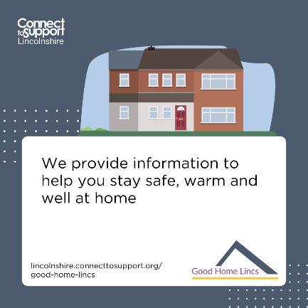
 | Good Home Lincs is part of the Lincolnshire Good Home Alliance. We’re a group of organisations working together to support all residents in the county to maintain, improve and adapt their homes, helping them stay safe, warm and well  For advice and support on your home, visit: https://lincolnshire.connecttosupport.org/good-home-lincs/  #GoodHomeLincs | 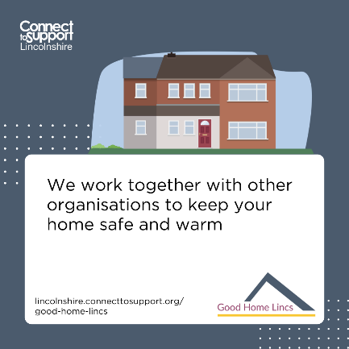
 | If you’re looking to make any improvements on your home, carry out general maintenance and repairs or even making adaptations you can find information through Good Home Lincs.  We’re here to help you stay safe, warm and well in your home. Visit: https://lincolnshire.connecttosupport.org/good-home-lincs/  #GoodHomeLincs | 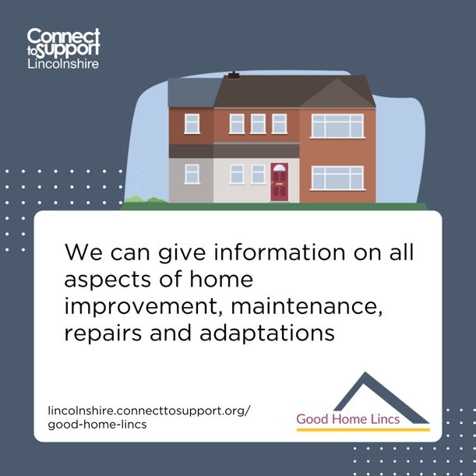
 | The healthy home assessment from Good Home Lincs can help you check your property to identify issues with its condition and give you the information you need to improve any issues you want to work on.  Visit https://lincolnshire.connecttosupport.org/good-home-lincs/healthy-home-assessment/ for more information and to complete your assessment today.  #GoodHomeLincs | 